

JamCheck®

**Project Document**

**Prepared by**

**Darwin Dallas**

**Rajae Henry**

**Karena Galloway**

**David Samuels**

**Daniel-Michael Palmer**

**Vocational Training & Development Institute**

**Software Engineering & Database Development**

**Lecturer: Trevoir Williams**

**December 22, 2022**

Table of Contents

**Meet Our Team** 2

**Entity Profile** 4

**Problem Definition** 4

**Proposed Solution** 5

**Product Functions** 6

**Design and Implementation Constraints** 7

**Project Assumptions** 7

**Dependencies** 8

**Functional Requirements** 8

**Non-Functional Requirements** 9

**Feasibility Study** 10

**Economic feasibility** 11

**Technical feasibility** 11

**Software Design Specifications** 13

**User Interfaces** 13

**User accounts and permissions** 16

**Hardware Interfaces** 17

**Software Interfaces** 18

**Database Design Specifications** 19

**Entity Relationship Diagram** 20

**Data Dictionary** 20

**References** 21

# **Meet Our Team**

David Samuels

Database Engineer

David is responsible for maintaining the security of the JamCheck® network databases he helps in preventing unauthorized access and activities, and upgrading data infrastructure. David also manages the volume of stored data, and ensures that the information would not affect the traffic flow and navigation.

Daniel-Michael Palmer

Network/cloud engineer

He oversees designing, developing, executing, and preserving the company's data management systems. He also helps to install and configure the relational database management system on the company's server.

Darwin Dallas

Database manager

Darwin develops and maintains the organizations' databases. He creates data storage and retrieval systems, troubleshoot database issues, and implement database recovery procedures and safety protocols. They also supervise the daily activities of database teams.

Rajae Henry

Database Programmer

Rajae is responsible for writing manuals to help coordinate, maintain, view, and update record sets stored on a computer server. He is also responsible for developing and testing modern database applications with advanced programming languages

Karena Galloway

Analysts and Data Scientists

Karena is responsible for collecting, organizing, and statistically interpreting information in databases. She uses specific extraction, analysis, and visualization tools as well as directly querying data using SQL.

## **Entity Profile**

JamCheck is Jamaica’s local provider of vehicle histories with the aim of making the used car market more transparent and our roads safer island wide. This marvel was founded and launched by Nathaniel Samuels in 2022 following the completion of his Master’s in Business Administration 2 years ago.

At JamCheck, the CV of a car is considered the vehicle history report, when purchasing and selling, as well as when dealing with insurance and financing concerns, it fosters transparency and confidence. This business can assist all parties in reducing risk, regardless of who is making the offer and demand. Apart from generating up-to-date, accurate car reports, JamCheck has partnered with the most popular used car dealers by connecting them with buyers and sellers of used cars.

This company possesses trained business and data analysts with over 10 years of experience analyzing used car market data and consumer statistics. Dealer Management System that enables the company to take control of the business and make quick decisions. Lastly, Network/ Cloud engineers are in charge of solving issues with network architecture and providing enhancements.

# **Problem Definition**

After doing research on the industry, we have learned that there has been an ongoing issue regarding transactions between buyers and sellers of motor vehicles. Buyers, also recognised as the new owners are experiencing a myriad of issues with their vehicles which were omitted during the exchange. This has caused the spawn of numerous used car dealer businesses who manage these transactions. These dealers are benefiting from the industry. But the question at hand is, do buyers of these used cars benefit as well?

Buying a used car in Jamaica, especially if it has been previously owned by someone in Jamaica is a significant risk. Imagine buying a car that was repaired after it met in a serious accident in Jamaica. How would you, the new owner, know that the used car you just purchased met in a serious accident?

Used car purchasers in Jamaica, especially those young and naïve, see a car that they like and without making an informed decision, purchase a car that would drain their pockets with repairs soon after owning it.

# **Proposed Solution**

Through constant research and deliberation amongst the group members, a solution was created for this project. Establishing an organized collection of structured information would be our primary objective in solving this problem since 100% of the cars in Jamaica are imported, the database searching for a vehicle

* Checks vehicle details (Colour, Chassis/vin number, transmission number)
* Checks for number of previous owners
* Checks for importation date
* Checks for previous and current Insurers
* Stores pictures of the car each time it gets insured and before being sold
* Checks for police records if ever stolen
* Checks servicing dates

## **Product Functions**

The system will be designed to give information on each car that enters the island logged using the Chassis/Vin Number, Engine Number, Colour Code and Transmission Number through Jamaica Customs. This database would be linked with every car insurance Company in Jamaica, the Tax Administration of Jamaica, the Transport Authority, and the Police Report System. This database will also be linked to a website giving its user the necessary information needed to purchase a used car. The following flowchart will show some features of the database that is linked to the website.

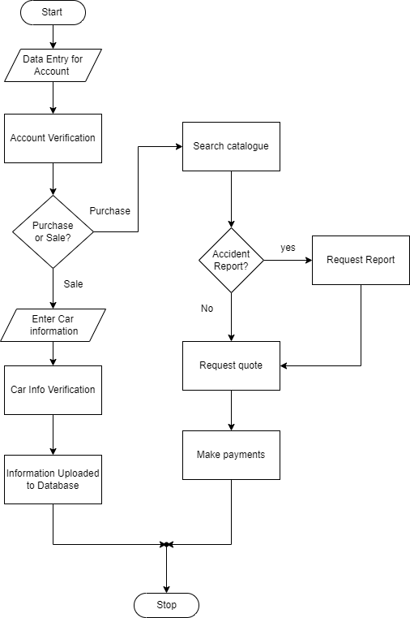

## **Design and Implementation Constraints**

The database system will receive its frequent updates to:

1. Improve the software design.
2. Performance improvement
3. Increase active responses
4. Add new features

## **Project Assumptions**

JamCheck® Database Management System project has the following assumptions:

* The database management system will be capable of storing a large and ever-growing number of records of Colour, Chassis/vin number, transmission number, Store pictures of the car and Check for police records if ever stolen, Check servicing dates
* The system will have a dedicated area to store the hardware for the database system.
* The company will have stable, fast internet service which can support the database management system.
* The company will have up-to-date computer hardware to set up and access the database.
* The database system will be accessible on tablets, laptops and computers on the company network.
* The database management system will ensure records are kept confidential.

## **Dependencies**

In order for the company to ascertain quality information about the cars that will be imported to Jamaica, JamCheck® will have to embark on a partnership with companies such as Auto Terminal Japan which is one of the leading vehicle inspection agencies in Japan. This partnership will allow JamCheck® to attain real-time and accurate information about the vehicles that will be imported to Jamaica.

Additionally, the partnership with Jamaica Customs Agency, Insurance Companies, Jamaica Constabulary Force, Ministry of Transport and Mining and its sub-agencies Transport Authority, and the Tax Administration will ensure the accuracy of information of each used vehicle that is in the Jamcheck system which improves our credibility and reliability.

# **Functional Requirements**

* The system allows the user to locate any vehicle based on vehicle type, make, and model.
* The system enables searching and sorting across all tables. There should be both simple and complicated queries available to perform tasks.
* The system should only allow authorized users to have access to read and write the database.
* Scalar functions are available in the system to allow users to generate price ranges of vehicles from highest to lowest priced vehicles.
* The server will automatically back up the database once 24 hours have passed since the last backup.
* The system will allow users to generate reports from the tables designed.
* The server shall log all changes to existing data.

# **Non-Functional Requirements**

* The system will demand a password change upon login if a user has not updated their password in 90 days.
* Only administrative privileges necessary to complete a job will be provided to certain users.
* To increase security, the web server will be separated from the database server to ensure isolation and avoid lateral movement.
* All web pages will take approximately 3 seconds to load.
* The login page for users should display their customer profile which includes all the vehicles they have registered.
* Users with customer profiles will be notified of interested buyers for their vehicles.
* Users with customer profiles will be notified of vehicles that have been added to the system that match their car search history.
* The system returns the results of a car search within 6 seconds.

# **Feasibility Study**

One hundred percent (100%) of the vehicles driven in Jamaica are imported and about eighty percent (80%) of those vehicles are used. These vehicles were imported from halfway across the globe from countries including Japan and Singapore just to name a few. These imported cars had previous owners with their ownership spanning over five years and approximately (90%) of these vehicles displaying over 90,000km on the odometer, if those values are true. This begs to question the quality of the vehicles being imported to Jamaica. According to an article published by The Gleaner; Jamaican used car customers are being deceived by unscrupulous used-car dealers who are rolling back the mileage generated on vehicles in the country of origin to sell on the local market at a greater value. Additionally, Lynvalle Hamilton, President the Jamaica Used Car Dealer Association (JUCDA) stated that his association has seen some imported vehicle and wonder how it is that they were inspected and passed (Titus, 2020).

Furthermore, in November 2021 the Consumer Protection Tribunal of the Consumer Affairs Commission ordered a Jamaica Used-Car dealer to pay more than seven million dollars ($7,000,000.00) after selling a damaged vehicle to a buyer. It was reported that after the buyer purchased the vehicle, they discovered numerous issues with the vehicle, then ordered an assessment to be done on the vehicle. On completion of the assessment, it was concluded that the vehicle met in a heavy collision in Japan and sections of the vehicles were refurbished in Japan before it came to buyer in Jamaica (The Jamaica Observer, 2021).

Consequently, the idea of JamCheck® was created to solve the issues Jamaicans are facing with these imported used cars. JamCheck® conceptualized, will see each imported used car having something like a passport or criminal record before being bought by a resident of Jamaica. For example, if an imported car met in a collision from its country of origin and was repaired, the details of the collision and repairs done to the car will be accessible through the company's website. This will allow our customers the opportunity to make a more informed decision regarding the purchase of the imported car.

## **Economic feasibility**

In this feasibility study, the cost and benefits of the project were assessed. This study shows a detailed analysis of all costs for various aspects of creating the JamCheck® website. These include hardware and software requirements, design and development cost, operational costs, and return on Investments.   
 Hardware and software requirements along with labor were easy to calculate for the creation of the website and database; Operational costs were known in advance and fitted within the budget for the client. The costs associated with the risks will become tangible during the development of the database itself when increasing human and technical resources are required to fix problems that crop up during the implementation phase of the system.  
 The benefits of JamCheck® System were not as easy to calculate as the development cost and the hardware and software requirements. However, with all costing addressed as stipulated by us, you would have started seeing a return on investments within 9 months.

## **Technical feasibility**

The technicalities that are required for the project are quite easy to assess. The start-up of the website will be coded using HTML, CSS, Bootstrap and JavaScript on the Microsoft Visual Studio platform. This software is free and only requires the programmer to set it up on a personal computer. After completing the programming end of the website, it will be hosted using Netlify website hosting. The only requirement JamCheck® is to pay hosting fees for the website.

The database component will be coded using SQL Scripts on the Microsoft SQL server Management Studio platform. This platform is free to download on any personal computer. The database will then be deployed to Cockroach DB which is an online Database Management System. This process of deployment will require little to no management, seeing that both software use SQL. JamCheck® will only be required to pay a subscription for the hosting. The database can now be connected to the website, as both Cockroach DB and Netlify can be linked using PHP. The below diagram will give appreciation of how JamCheck® will operate (*Technical feasibility in software engineering: Things to consider before development starts* 2022).

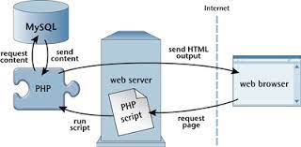

# **Software Design Specifications**

## **User Interfaces**

The accessibility of the JamCheck® database must be consistent for the company to be able to achieve its mission of giving its customers quality and timely information on imported used cars in Jamaica. For this to happen, JamCheck® saw that the most effective way of distributing access to the database is through a website. The use of PHP (Hypertext Preprocessor) we will connect the website to our SQL database, allowing our customers to have real-time access to information.

These are some of the interfaces the user will encounter during their search for a used car.

Picture 1: Login in Webpage

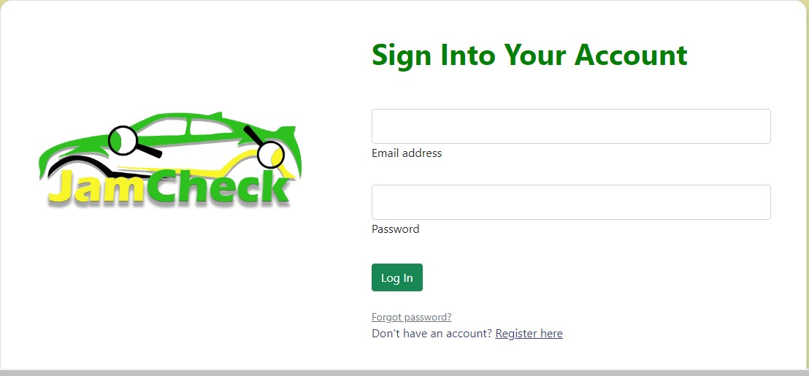

Picture 2: Sign Up Page

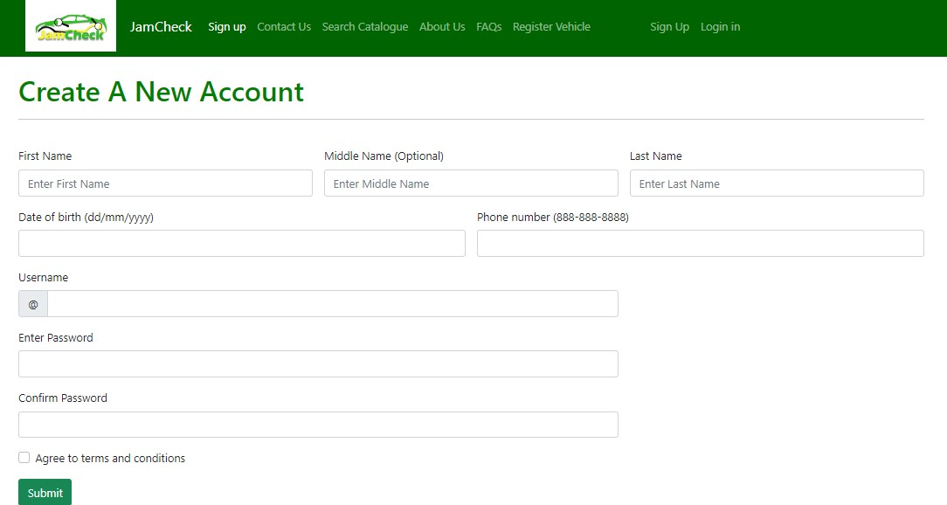

Picture 3: Search Catalogue

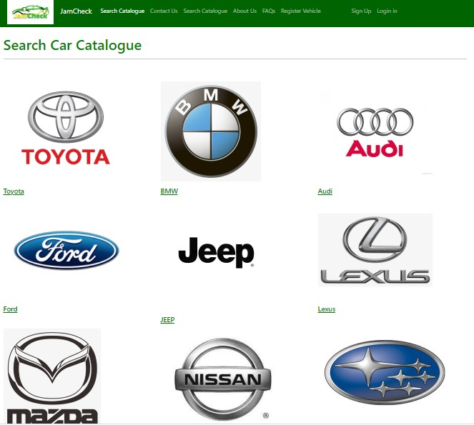

The user will be able to search the catalogue of cars by clicking the car logo tab they desire.

Picture 4: Register Vehicle

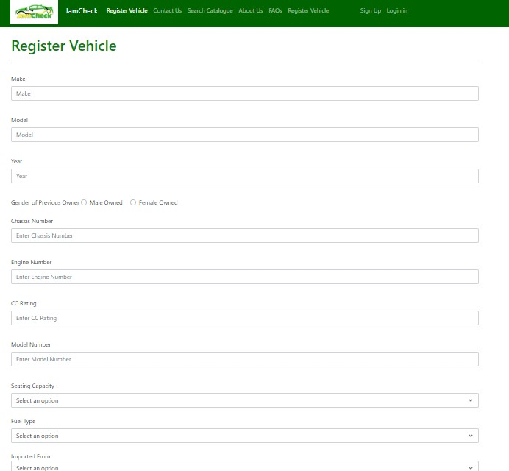

This section of the website will allow customers the option register a vehicle they own for sale

Picture 5: Displayed Car 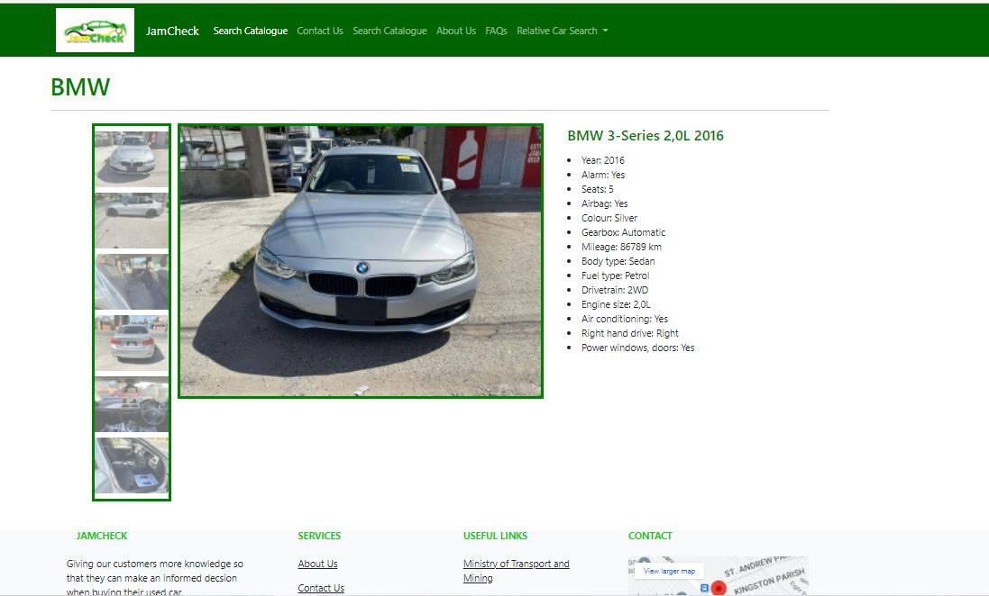

This picture displays a mock-up of how the website will display a car from its database

## **User accounts and permissions**

If the customer is new to the website, they must sign up/create an account to access the information on the database. After creating this account, a verification code will be sent to their email address that was used in the sign up to finalize the User authentication. That verification code should then be entered to verify the account the user created using the website. Additionally, each email login will have only one account. So, if the user requires two accounts, then they would have to create another account using another email address.

The access that each customer would have access to all cars in our catalogue. Additionally, if a customer decides to sell a car on the website, they can use the register car option like the web page shown in picture 4 in this document. However, the information submitted on car registered will be combed through by or technicians. To ensure the information is current, legal and has not been tampered with; it will be compared with the Government's systems. These include but not limited to Tax Administration, Transport Authority, Jamaica Constabulary Force and Jamaica Customs. This check will eliminate possibility that the car may have been stolen or otherwise. When the information is verified then the cars’ information will be posted on website.

## **Hardware Interfaces**

**Hardware requirements for Host**

Most companies today have gone from hosting their own databases and website to outsourcing these services to cut overhead cost and other management hiccups which may happen in the future.

The company will do startup coding for databases using Microsoft SQL and HTML coding. The hosting for the website will be done through Netlify whilst the database will be hosted through Cockroach DB rooted to Netlify.

Cockroach DB is a cloud-native distributed SQL database designed to build, scale, and manage modern, data-intensive applications.

Netlify is a remote-first cloud computing company that offers a development platform that includes build, deploy, and serverless backend services for web applications and dynamic websites

**Hardware requirements for user to access the website**

The database system will be able to be able to run on any system with these listed requirements

The minimum Computer hardware specifications are:

* Intel Pentium
* 4GB RAM
* 32 Hard Disc Drive
* Access to internet

The minimum mobile hardware specifications are:

* Quad Core 1.2GHz
* 4 GB RAM
* Access to internet

## **Software Interfaces**

The component of this software consists of a user interface and the version is a V1.0. however, this software will have a database name, JamCheck® system.  The SQL (Standard Query Language) tool will be used to interact with the database. The configuration data and documentation libraries will be used for the software development.

A logical data type will be used, if the data resource uses a data type that is not provided then the system will automatically define what is a data type and the data type that should be used.

An error handling method will be used to identify the errors that will be raised by the resources; hence the error handling method will allow all the errors to be listed and defined in a dictionary.

A quality attribute characteristic will be used to document the quality of the interface such as the performance and reliability, the interface may know to the user. The information will be in the form of constraints on implementation of elements, which will realize the interface.

# **Database Design Specifications**

The company decided to use the Relational Database Design in making this project a reality. The reasons for this is to offer structure, accuracy and ease of use. The database had to meet our systematic requirements in offering quality information to its users. So, this database’s main objective is to provide information on used cars that are entering Jamaica for sale. For the objective to be met, it would require the company to partner with international and local companies.

Additionally, the table selections were done based on research conducted on how to make our concept come to life. The database surrounds information on used cars, so we had to have a table to store this information and the columns in that table would have information of each car to include chassis number, transmission, make, model and especially the odometer reading and accident reports.

Attaining this information from the cars' country of origin will remove the ability of the used car dealer to conduct odometer fraud or profit greatly from selling badly wrecked cars that were repaired to disguise major issues.

We also decide to have a Transaction table to properly account on the type of transaction each car is slated for, either buying or selling. The design would provide efficiency when running certain Queries or conducting searches within the database.

## **Entity Relationship Diagram**

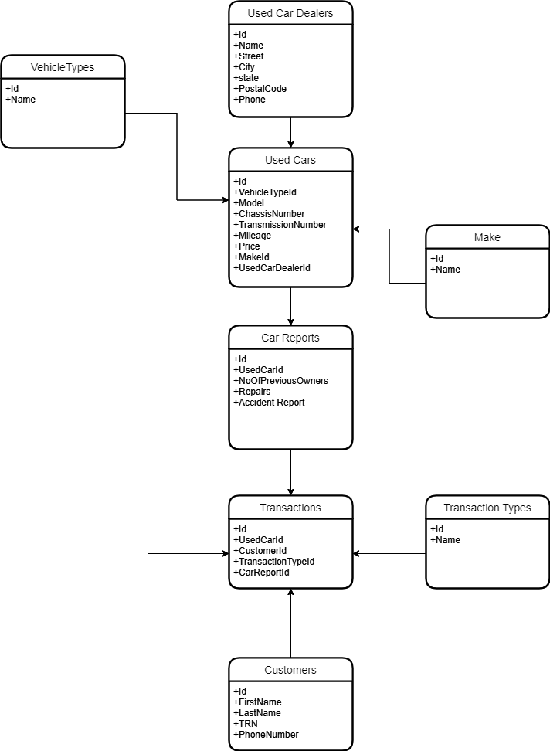

## **Data Dictionary**

Please refer to the excel document ‘Data Dictionary’ attached.

# **References**

A guide to functional requirements (with examples). (n.d.). Retrieved December 22, 2022, from <https://www.nuclino.com/articles/functional-requirements>

Editor. (2022, January 6). *Technical feasibility in software engineering: Things to consider before development starts*. AltexSoft. Retrieved December 22, 2022, from <https://www.altexsoft.com/blog/technical-feasibility/>

The Jamaica Observer (2021, November 19). *Used car dealer ordered to pay more than $7M after selling damaged vehicle to buyer*. Jamaica Observer. Retrieved December 22, 2022, from <https://www.jamaicaobserver.com/latest-news/used-car-dealer-ordered-to-pay-more-than-7m-after-selling-damaged-vehicle-to-buyer/>

Titus, M. (2020, May 29). *Car mileage fraud in overdrive - as cracks open up in screening, dispute emerges over inspection certificates*. Car mileage fraud in overdrive - As cracks open up in screening, dispute emerges over inspection certificates | Lead Stories | Jamaica Gleaner. Retrieved December 22, 2022, from <https://jamaica-gleaner.com/article/lead-stories/20200529/car-mileage-fraud-overdrive-cracks-open-screening-dispute-emerges-over>